**Network Programming Lab**

**End Term Examination**

28-05-2021

20181CSE0621

Sai Ram. K

6-CSE-10

**Set – B**

**Question: -** Mahima’s laptop was connected to network1(IP address= 192.168.0.0/24) with router1(WEP=2342342341), later she leaves that network and moves to other network2(IP address=20.0.0.0/10) with router2(2345678901), help Mahima to connect to router2 automatically using wireless connection.

Complete the following –

Construct two networks with given IP address

Configure wireless router

Connect laptop to router 1 using wireless connection

Remove laptop from network 1 and connect to network 2

Check connectivity using ping

**NS 2 :-**

Simulate a eight node point to point network with the links connected as follows: n0 – n1, n1 – n2, n1 – n4, n1-n5, n1-n6, n6-n7 and n4-n3. Apply TCP agent between n0 – n3 and UDP agent between n5 – n3. Apply relevant applications over TCP and UDP agents changing the parameter and determine the number of packets dropped by TCP / UDP.

Question 1]

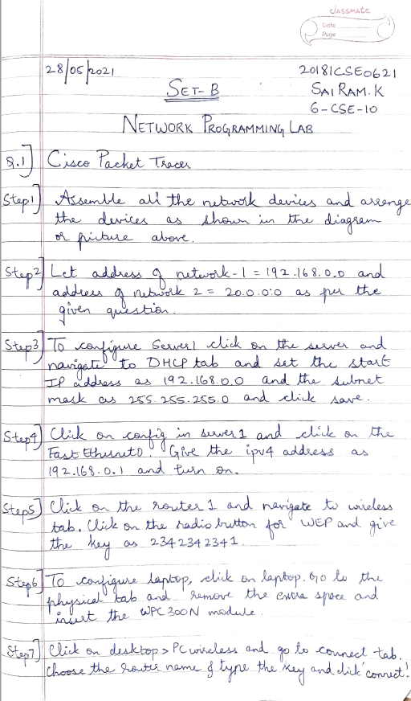

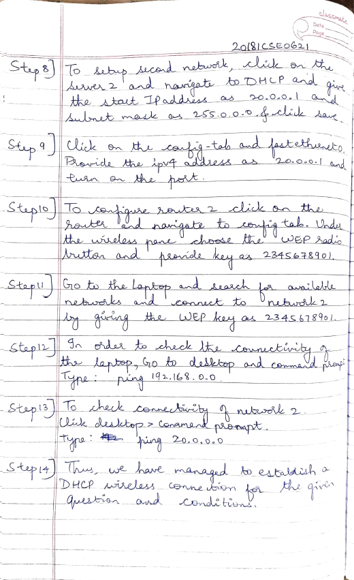

Topology:

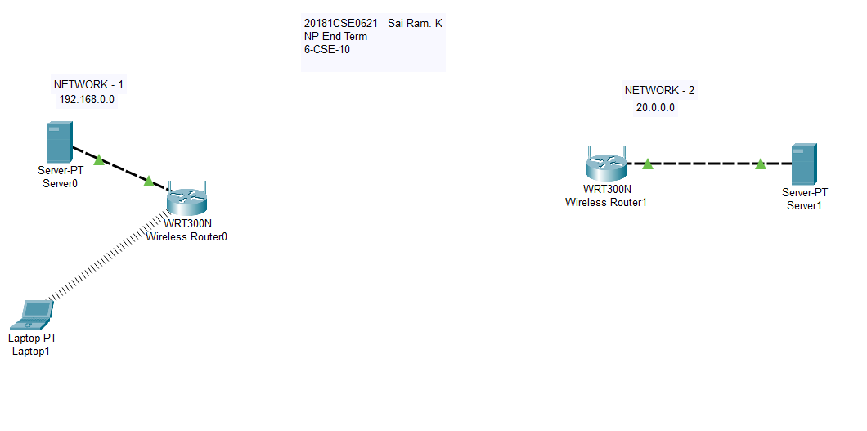

Step 1: Configuring DHCP

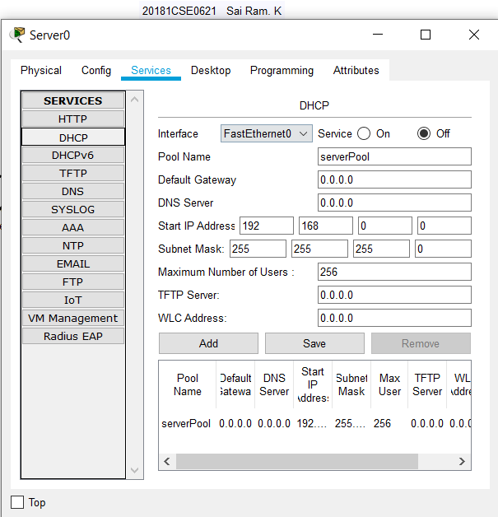

Step 2: Configuring Fast Ethernet

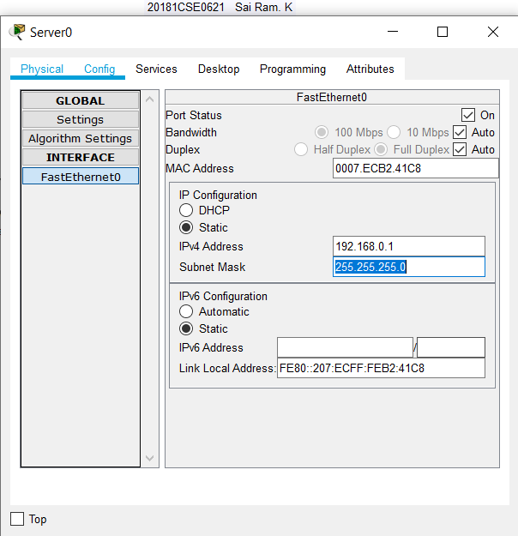

Step 3: Wireless Router WEP configuration

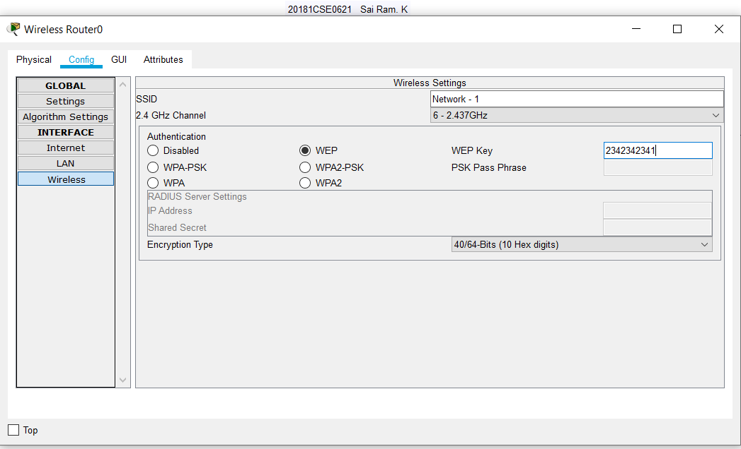

Step 4: Configuring Laptop (physical)

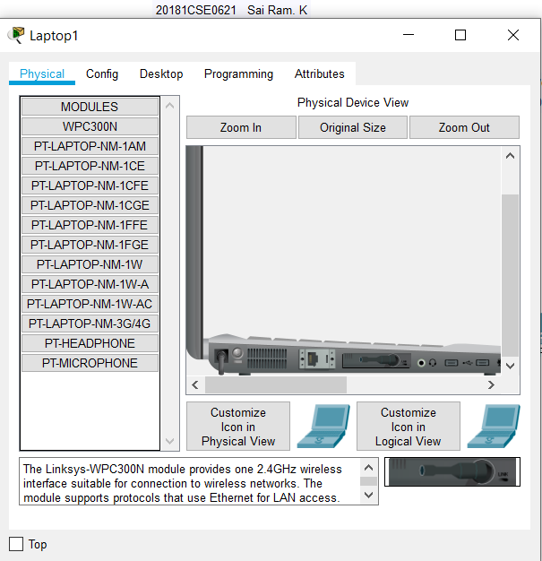

Step 5: Connecting Laptop to Wireless Network

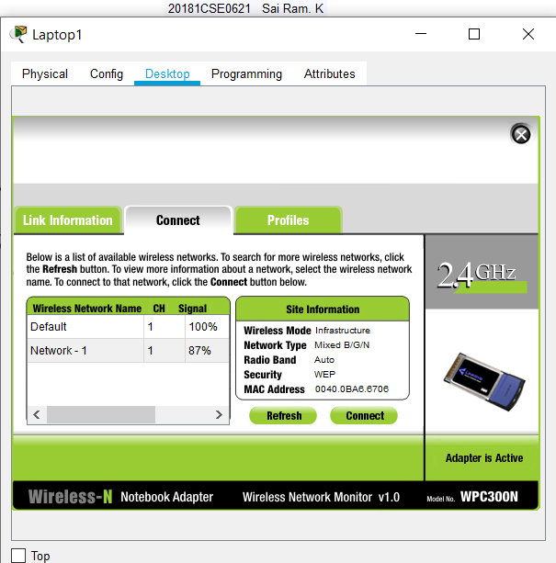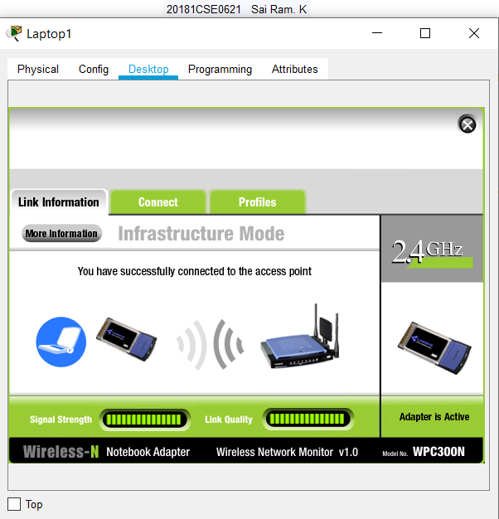

Step 6: Configuring Server 2 fast ethernet & DHCP

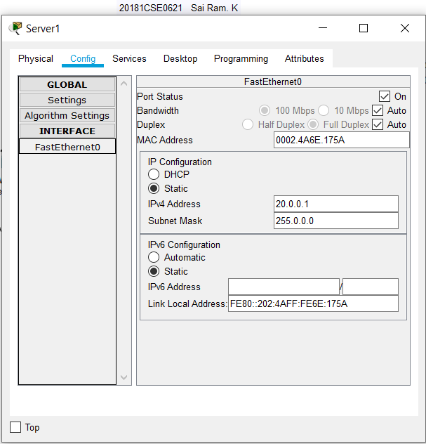

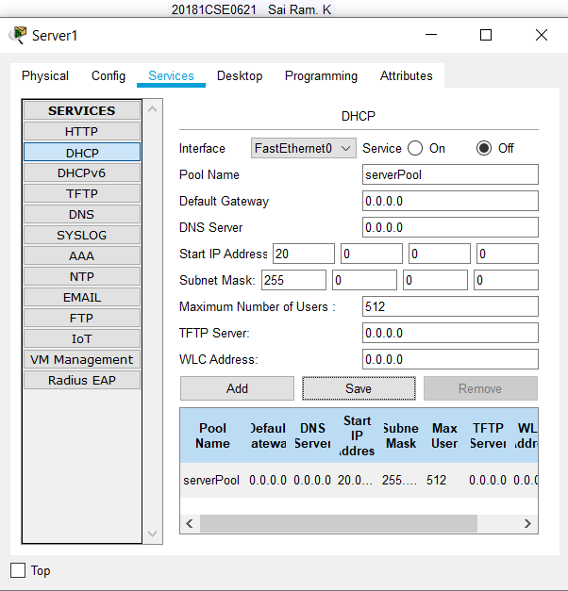

Step 7: Configuring Wireless WEP for router 2

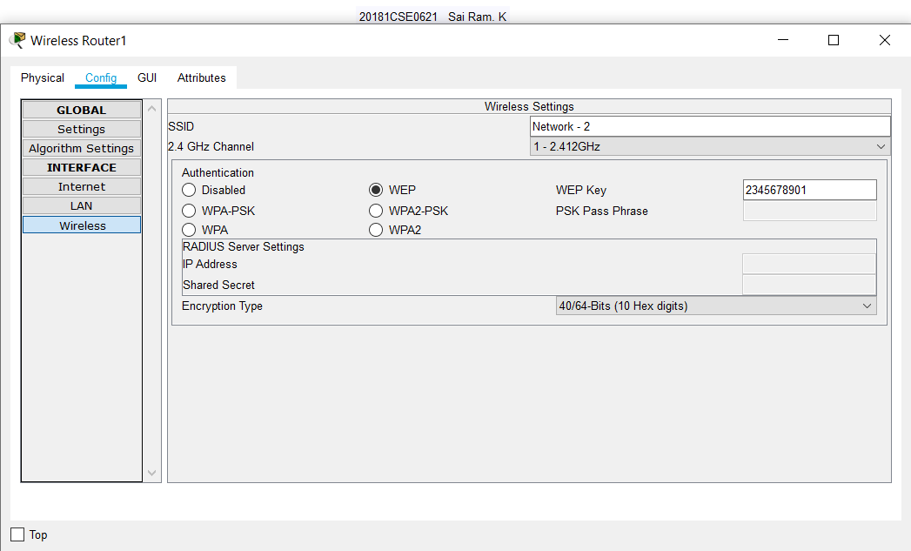

Step 8: Connecting Laptop to Network 2

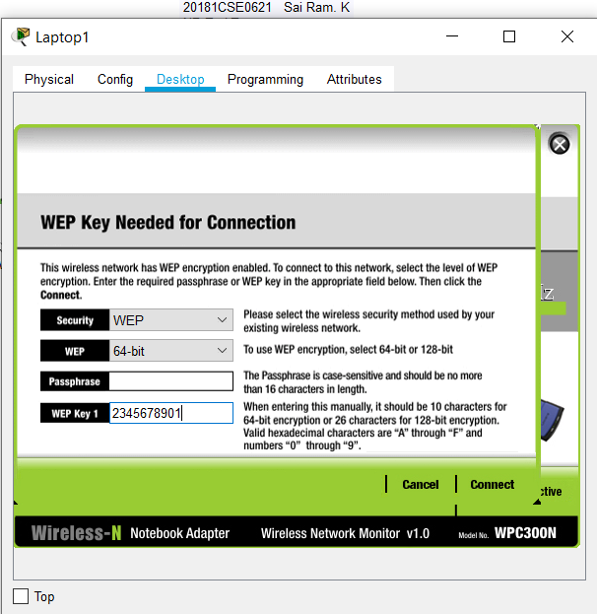 

Step 9: Checking ping for Network-2

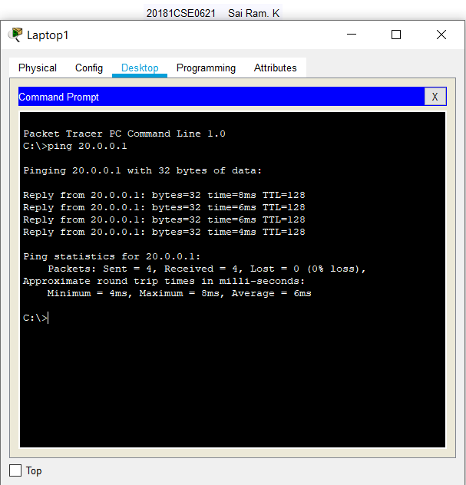

Step 10: Checking Network-1 connectivity

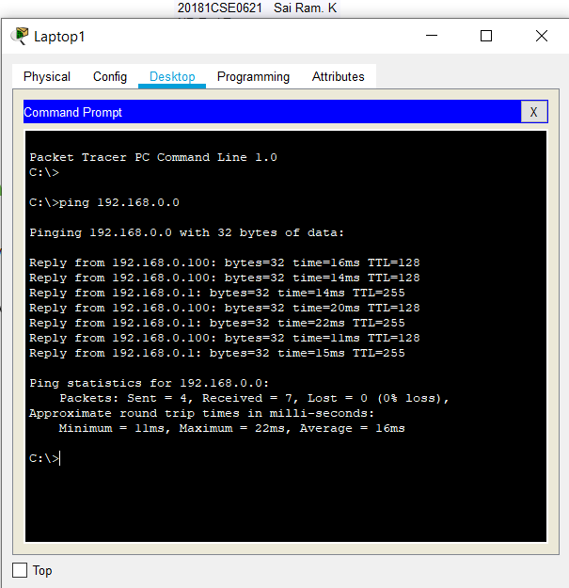

**Final Output**

Stage 1:

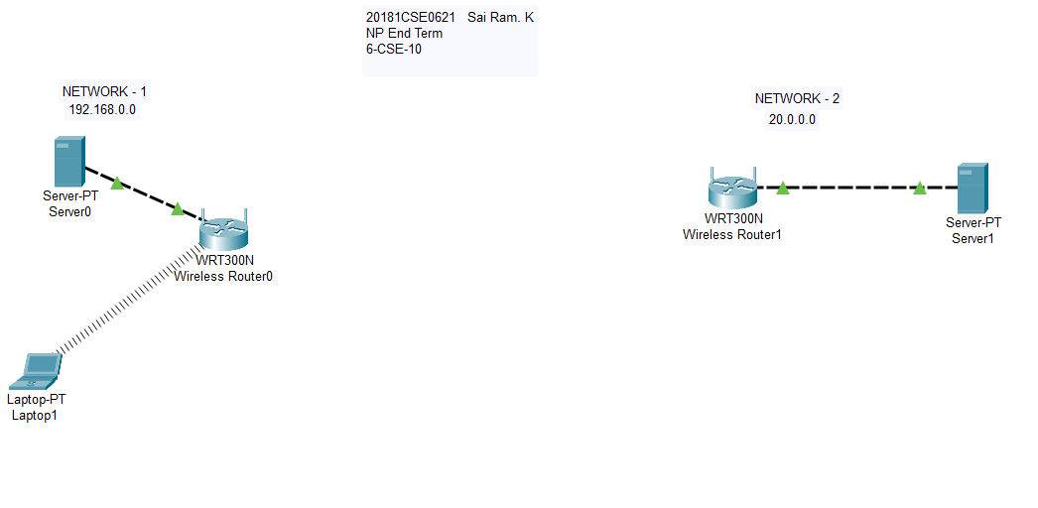

Stage 2: -

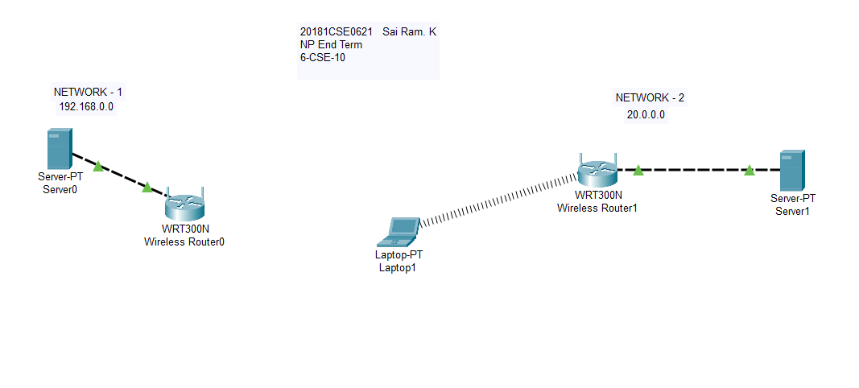

Question 2] **Network Simulator -2**

**TCL: -**

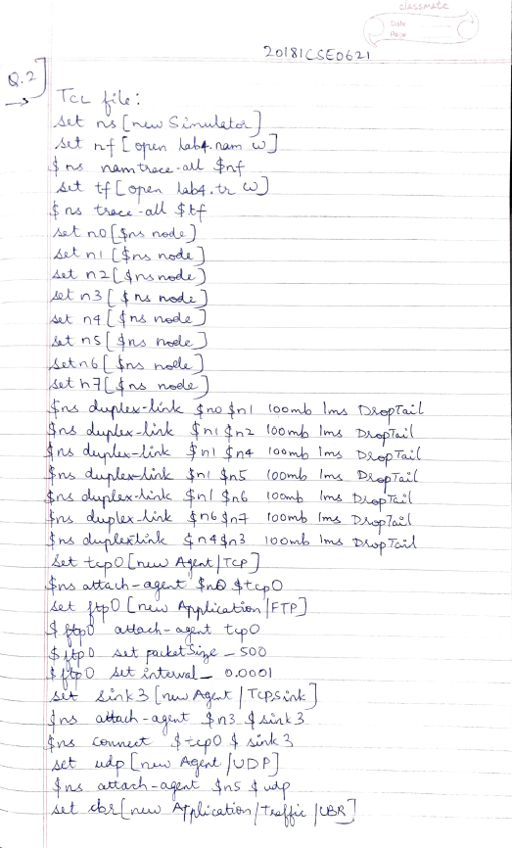

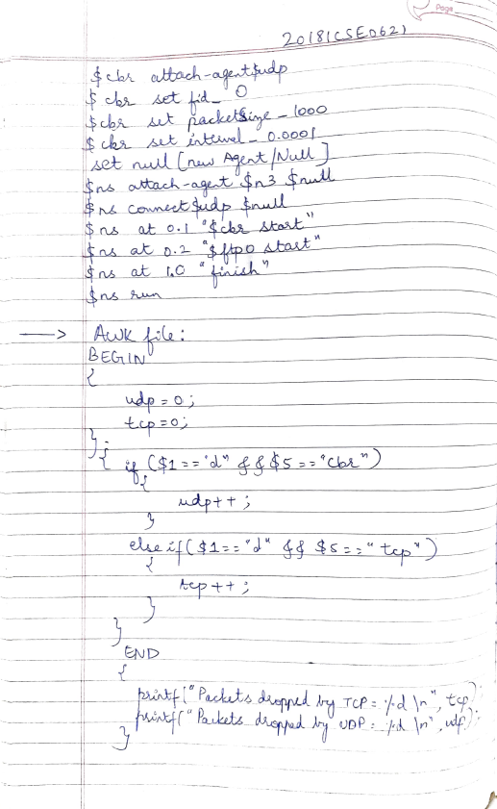

**Steps for Execution**

